Sun Bird Travel 239-430-2000         Howard Friedman 240-401-9342

THE TOUR IS DESIGNED FOR 18-22 PEOPLE

​

SEPTEMBER 9th (Wednesday) – Depart USA

​

SEPTEMBER 10th (Thursday) - Arrive San Sebastian.  Transfer to the Hotel Londres in the heart of old town. Transfers will be           arranged for those who arrive on the 1:00 PM plane from Madrid.  Join the group for an included lunch. The rest of the day is at leisure.

​

OVERNIGHT HOTEL LONDRES, SAN SEBASTIAN

​

LUNCH INCLUDED - DINNER ON YOUR OWN

​

​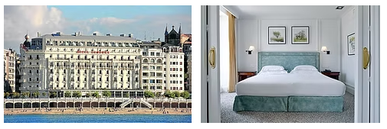

​

SEPTEMBER 11th (Friday) Gourmet Breakfast at the hotel.

After breakfast you will be able to don your “chef’s hat” as we walk to the MIMO Restaurant for a Tapas preparation class that will include a delicious lunch at the conclusion of the lesson.

Dedicated Pintxos “Chefs” at MIMO at the Maria Cristina Hotel cooking class in San Sebastian.

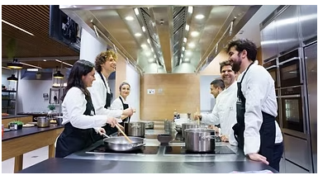

​

​    Maybe venture out this evening small groups to sample PINXOS in Old Town.​​

​

LUNCH INCLUDED - DINNER ON YOUR OWN

​

OVERNIGHT HOTEL LONDRES

​​​​​​​

​​SEPTEMBER 12th (Saturday) – After your sumptuous breakfast, a short 30 minutes chartered bus will take us to the lovely fishing village of Getaria and Bodega Hika. With vineyards in the picturesque Oria River Valley. This tiny winery has only 7 hectares of vineyards producing iconic Txakoli wines from native grapes of the Basque country.

​ 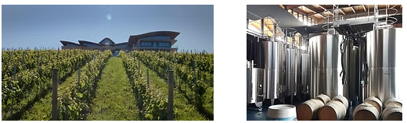

After our tasting and vineyard walk, we will enjoy lunch at Elkano Restaurant, which has earned a Michelin star and since 1964 has made: “The reason for our work comes from our environment … based on people who value the wisdom and knowledge of it” and who bring them the finest ingredients available which are then prepare it with “minimal intervention”.

Traditional, wood fired grills prepare the finest seafood and meat entrees.

You will have free time to explore this beautiful fishing village before returning to San Sebastian

​  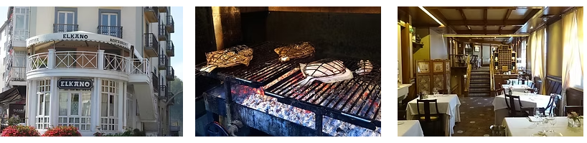

                                            ​​LUNCH INCLUDED - DINNER ON YOUR OWN

​

                                                OVERNIGHT HOTEL LONDRES​

​

​​SEPTEMBER 13th (Sunday) *Pack Your Bags* - After breakfast, a short ride to Bilbao will take us to the Guggenheim Museum for a guided tour and then lunch at the Narua: a Michelin starred restaurant within the Guggenheim Museum.

​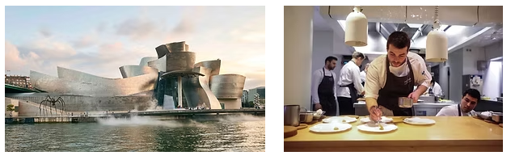

​

After Lunch we will continue to the town of Haro and check into the Eurostars Los Agustinos.

​ 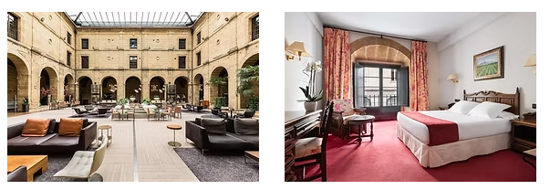

​

​ OVERNIGHT EUROSTARS LOS AGUSTINOS​

​

LUNCH INCLUDED - DINNER ON YOUR OWN

​​​​

SEPTEMBER 14th (Monday) After Breakfast at the hotel we will drive to Haro for a guided tour and tasting at Bodegas Muga.

Our visit this morning will include the one of Rioja’s most iconic large wineries. The guided tour will include a tasting of its wines as well as its barrel making facility. The wines you will taste here will show the high quality that even a large winery can produce with dedicated viticulture and wine making staff.

​

​ 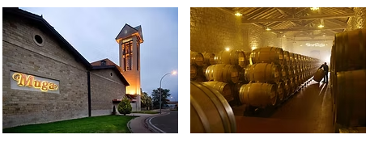​

​We will travel on to Logroño where you will enjoy lunch on your own before a visit to Bodegas Exopto: …”a project founded in 2003 by Tom Puyaubert, with the aim of recovering and enhancing old vines on the slopes of the Sierra Cantabria and Monte Yerga. Based on sustainable and environmentally friendly viticulture, our work philosophy aims to express the multitude of terroirs that make up the D.O.Ca Rioja. Returning to a work of artisanal vines in order to produce honest and authentic wines is the objective we pursue based on passion and enthusiasm.”

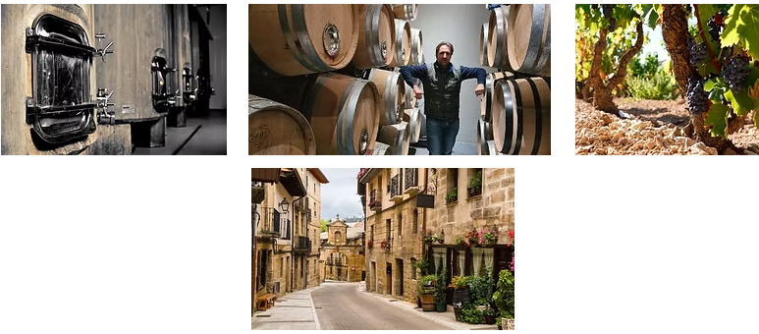

​​​​​​

LUNCH AND DNNER ON YOUR OWN

​

                                     OVERNIGHT HOTEL EUROSTARS LOS AGUSTINOS                                     ​

​

​​​​​​​                                                      ​

SEPTEMBER 15th (Tuesday) – ​*Pack your bags* - Enjoy a leisurely breakfast this morning, we will leave for a 1-hour ride to Burgos and check into and check into the beautiful NH Collection Palacio de Burgos located just a short walk to the center of Burgos and a visit to the Burgos Cathedral.

At an elevation of over 2800 feet, Burgos is situated at a crossroad along the Camino de Santiago, the historic      “Way of the Cross”.  The cathedral in Burgos was begun in 1226 and not finished until 1493!  It has been declared a “World Heritage Site” by UNESCO and is one of the most extraordinary in all of Spain.  In its treasure room can be found a 15th century monstrance that is said to be gilded with gold brought from the New World by Columbus.  Here you will also find the tomb of El Cid, Spain’s greatest national hero.

​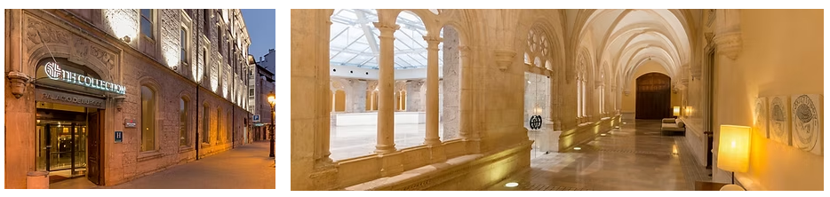

Later we will enjoy Lunch at Michelin restaurant Cobo Tradición located in the medieval heart of the city.​​

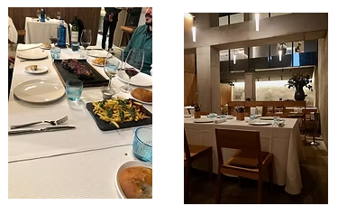

​​                                              The afternoon and evening are free.

                            ​​​​​​​​    LUNCH INCLUDED - DINNER ON YOUR OWN

​

ACCOMMODATIONS AT THE NH COLLECTION PALACIO DE BURGOS

​​​​​​​​​

SEPTEMBER 16th - (Wednesday) ​After breakfast we will travel to 1-hour Gumiel de Mercado to visit Bodegas Valduero for a tour of the cellars, a wine tasting and lunch.  A multi-course gourmet lunch will be served with meticulously paired wines.  These wines have often received 90 points or higher from Robert Parker, and your tasting and vineyard tour will be guided by Yolanda Valduero, the winemaker and daughter of the winery owner, and/or the export manager.

  On past tours, the lunch at Bodegas Valduero is always one of the highlights of the trip.  The whole range of their wines will be opened and paired with an incredible multi-course lunch served at the winery.  The guests enjoyed the wines so much that they ordered several cases of wine which they purchased when they returned to the U.S.  In fact, there is a very special barrel program

that you will learn about.

​                    CAROLINA AND YOLANDA AT THE VALDUERO WINERY

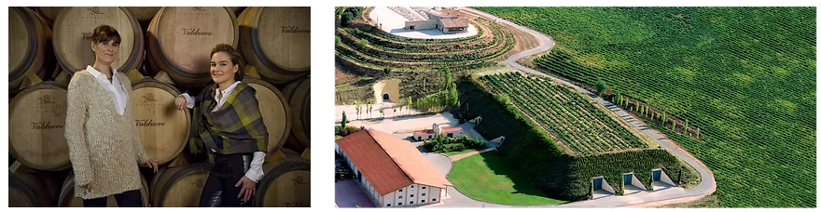

​​​​​​​

                              MULTI-COURSE LUNCH INCLUDED - DINNER ON YOUR OWN

​

ACCOMMODATIONS AT THE NH COLLECTION PALACIO DE BURGOS

​

​SEPTEMBER 17th - (Thursday) After breakfast we will travel one hour to Pedrosa de Duero for a tour of the fabulous cellars of **Pago de los  Capellanes** and a tasting of their very special and highly rated wines from Ribera del Duero and now, some delicious Godello white wine from Valdeorras.

In the 14th century, a chaplainry existed in the village of Pedrosa de Duero just 1 mile away.  The villagers donated small parcels of land to the chaplains for their work and, over time, these holdings became quite large.  About 500 years later these lands were given back to the village, but they retained the name “Land of the Chaplains”.   The present owners, the Rodero family, purchased the lands from the village and built a magnificent winery using the finest equipment and the most perfect cooperage to make some of Ribera del Duero’s finest wines.

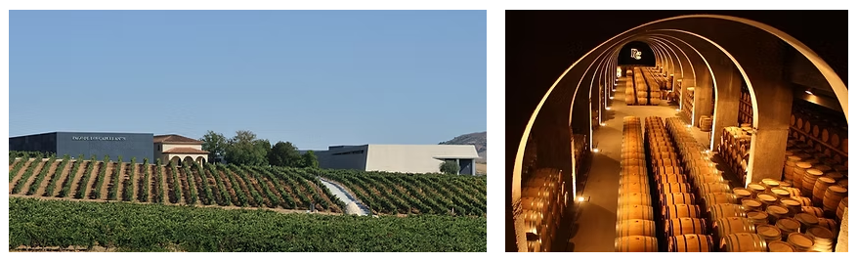

​THE CELLARS AT PAGO DE LOS CAPELLANES

 These wines have consistently received extraordinarily high praise from the world’s wine press and in the past have been among those wines on the Wine Spectator Magazine’s “Top 100” list.  In 2012 and again in 2016 this winery was “Winery of the year” for Wine & Spirits Magazine. Afterwards we will return to Burgos where you will be free to enjoy more of the city’s charm.

 Pago de los Capellanes has only produced red wines for its entire history, but just recently a winery was purchased, and vineyards developed to produce white wines called “O LUAR DO SIL” They are made with Godello grapes developed both in stainless steel and French oak barrels.  You will enjoy these wines at the tasting in the winery.

After our visit, a short drive to Peñafiel will take us to lunch at the timeless **Molino de Palacios** restaurant.

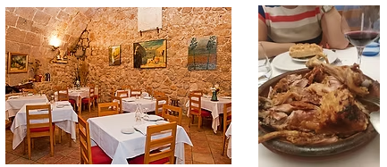

[Molino de Palacios | RESTAURANTE](https://molinodepalacios.com/restaurante/)​​​​​​​​​

​

September 17th continued

This afternoon we sample the wines of **Pago de Carraovejas**

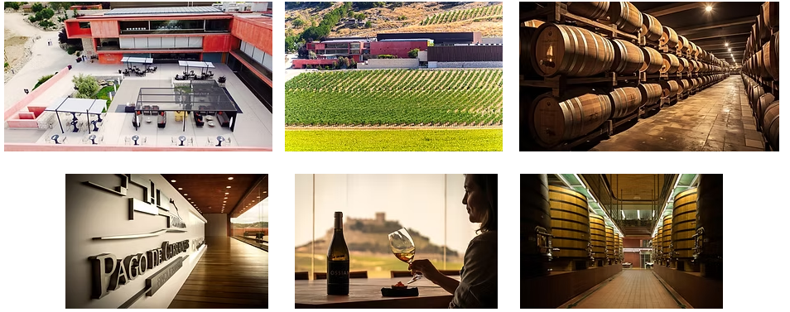

      When I first began my interest in Spanish wines, it was **Pago de Carraovejas** that was my introduction to the wines of Ribero del Duero. They were extraordinary then and they have continued to be of the highest quality in the D.O.

“The vineyard is planted at an average height of 850 meters above sea level on a hillside perpendicular to the Duero River, which crosses the land in an East-West direction. The grapes are from three varieties: Tempranillo, Cabernet Sauvignon and Merlot.

We continue to plant vines in those areas of …that allow it, always endeavoring to improve and fine-tune adaptation processes year after year. To do that we mass select the clones from the best plots…to create our wines.

Permanently restructuring and upgrading the estate according to the tenets of precision viticulture are the foundation for our future.

All these factors, the expert work contributed by all the estate personnel working in the vineyard and our careful and meticulous wine making process are what define the “Pago de Carraovejas” as reflected in its wines.”

​

​​​​​

LUNCH AND MORNING AND AFTERNOON WINE TASTING INCLUDED

DINNER ON YOUR OWN

​

ACCOMMODATIONS AT THE NH COLLECTION PALACIO DE BURGOS

​​

SEPTEMBER 18th (Friday) *Pack your Bags*After Breakfast we will travel to La Seca and the

**Bodega Javier Sanz.**

Spanish red wines have dominated the country’s presence in the U.S. market for many years, but lately new winemaking techniques and resurrection of indigenous clones long absent from producer’s references have markedly changed that view of the Spanish wine industry.  It is an interesting footnote to the production of white wine in the D.O. of Rueda that it was with the dedication of the director of Marques de Rascal and his work with a French Oenologist, Emile Reynaud that the production of high-quality wine from Verdejo – Rueda’s principle grape – began.

At Bodega Javier Sanz, this dedication to the extraordinary quality of wine that could be produced in Rueda from modern viticulture practices is its mantra.  Painstaking work in the vineyards to ensure the best quality grapes and the inclination to intervene as little as possible in the natural winemaking process have assured the production of Verdejo with the delicate, crisp gooseberry flavors for which it is famous.

​

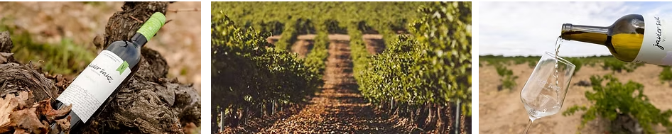

​​

Javier Sanz has dedicated his winery to the production of wines from pre-philloxera vines and the recovery of varieties that have almost become extinct.  His Malcorta wines are the culmination of this effort and represent a style of Rueda white wine that - but for his interest - would have disappeared.

 A fabulous visit to the original, 19th century winery has been arranged with a tasting of the superb quality Rueda produced there. We will visit the vineyards which are the very special heritage of Javier Sanz’ wines and we will enjoy a tapas with our tasting at the winery.

After our visit we will travel on to Madrid.

We will stop in **Segovia** on the way to explore and have lunch on your own.

​

WINE TASTING WITH LIGHT TAPAS INCLUDED – LUNCH AND DINNER ON YOUR OWN

​

ACCOMMODATIONS AT THE WELLINGTON HOTEL MADRID

​

​

​

​

​

​

​

​ 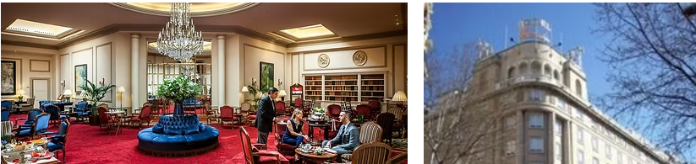

​

​​

The Wellington is by any standard a remarkable hotel.  This elegant 5 star hotel in the heart of the sophisticated Salamanca shopping area of Madrid exemplifies the ability to frame uniquely modern dining experiences with the highest of old world excellence of service and elegance of setting.  Enjoy lunch, dinner, an evening cocktail or even a relaxing swim on the Wellington Terrace. The Kabuki Wellington offers the best sushi in Madrid and is the proud recipient of a Michelin star.  The Goizeko Wellington is the result of “a culinary union between Jose Santos and Chef Abel Maretlloti and serves innovative and seasonal Basque Haute Cuisine.”

​

​

SEPTEMBER 19th (Saturday) After Breakfast please enjoy a day in Madrid on your own. We can help you book an optional tour.

  You might enjoy a tour of the Prado, Reina Sophia or El Escorial. Maybe just enjoy some last minute shopping.

At 2:00 we will meet at the Wellington for Lunch in Retiro Park OR have a farewell cocktail party. TBA

​

ACCOMMODATIONS AT THE WELLINGTON HOTEL MADRID

SEPTEMBER 20th (Sunday) Travel Home or to your next destination.  It has been our pleasure to travel with you for the past 10 days.

  I hope you have gained some of the same exuberance that I feel every time I visit.

As the Spanish say: “Buen Viaje” and may your travels continue to give you glimpses of our “WONDERFUL WORLD”

​

​

​

​